Remarkably Resilient™: Community Matters
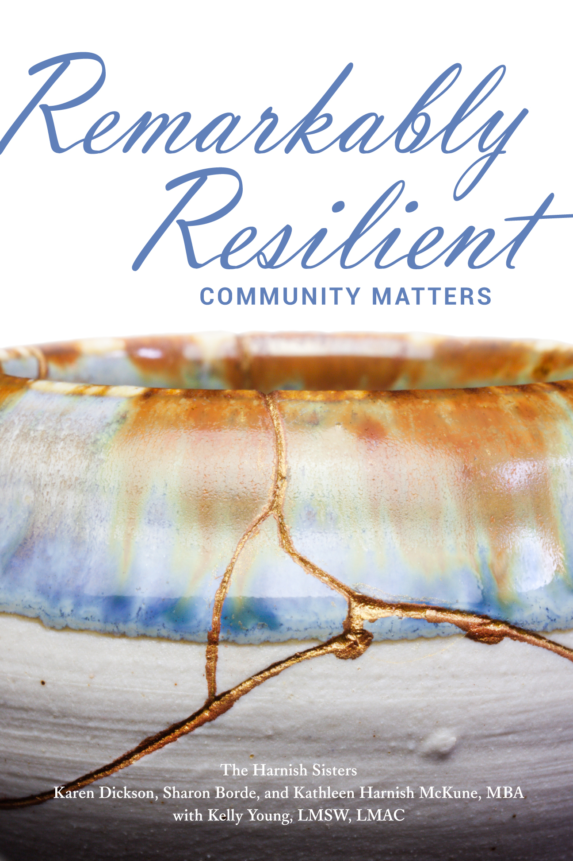
Many questions had nagged me and my sisters about our childhood home riddled with multi-generational incest, abuse, and neglect.
The question of “How were we able to break the cycle of abuse in our paternal family?” was answered in part by the role that community plays in building resilience.

Neuroscientists hinted at it in the extensive reading and research my sisters and I have done in our Remarkably Resilient™ work. Our lived experience confirmed it. And its significance led to our tagline: Community Matters.

Scientists, physicians, and researchers that have studied sustained trauma tell us it takes only ONE safe, consistent, loving adult relationship to help a child build resilience when in a toxic stress environment.

My two sisters and I each had one of those relationships with a community member from our small western Kansas town of Kinsley. Mine was Bill, the local entrepreneur and his wife, Joanna, whom I worked for during high school. Karen’s was the local dentist and his wife. Sharon’s was her friend, Sarah, and her father, Gus, that owned the local grocery store.

Not only did they employ us so we could buy many of the basic things we needed, they also showed us what a safe, loving adult relationship could look and feel like. We all three agree – these individuals (plus several of our teachers) saved our lives. RELATIONSHIPS are key to resilience.
Our call to action to our community: Be the ONE!

Mental health providers and practitioners have known for years the healing and grounding role of nature, therapy, and the active concern of others. Our lived experience confirms this. Another “R” in our Resilience journeys has been RECOVERY.
Our call to action to our community: Provide the places, spaces, and graces for recovery.

The third “R” is that of RESPONSE. Each of us had our own, unique response to what was happening in our childhood home. I had the memory eraser. Sharon got lost in books. Karen left her body and traveled to a place of beauty and peace. As children, we did not have a choice – we had a response that helped each of be resilient.
Our call to action to our community: Respond with action. Adults have more choices – choose to respond with action when you see or suspect incest or abuse.

The fourth and final “R” in our ongoing Resilience journeys is REGULATION. The information is clear on this “R.” Dr. Bruce Perry’s 2020 keynote address at the Kansas Governor’s Conference for the Prevention of Child Abuse and Neglect reiterated…
Our call to action to our community: Teach regulation to everyone.

Over please. Visit www.remarkably-resilient.com for more information.
From “Moving the Neuroscience of Trauma Into Action”, white paper by Kathleen Harnish McKune and Marsha Morgan, 2018
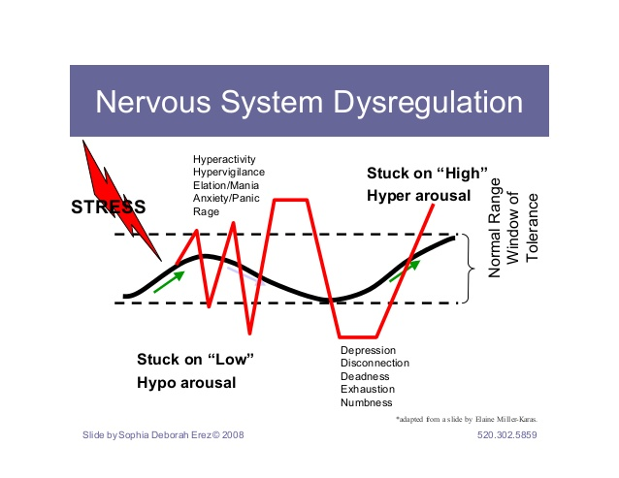

What We Know: Dysregulated stress-response systems are toxic to the brain and the body. What does dysregulation look like? Feel like? For some people, it feels like they are stuck on “high” (hyperactivity, hypervigilance, elation, anxiety, panic, rage) – or they feel they can be “set off” in an instant. For others, it feels like they are stuck on “low” (depression, disconnection, exhaustion, numbness) – or that a “low” state can be easily triggered.

Moving Into Action: Recognize when you feel dysregulated and work to get back into regulation. The optimal time to teach emotional regulation is ages 3 – 30 months (David Sousa, How the Brain Learns). However, at any age learning to self-calm and self-regulate is important for helping move from the Lizard brain (fight, flight, freeze) to the Wizard brain (where you can think better – though remember this is still developing in people until age 25 - 30). Telling someone to calm down doesn’t work. Teaching someone a set of emotional regulating skills they can call upon when they feel dysregulated does work.

What Do Regulating Skills Look Like and Sound Like? There are lots of options to choose from – creative and natural ways to enhance what we already do naturally to self-calm, such as repetitive motions or sighing, all based on the rhythmic and repetitive patterns that resonate with neural patterns. Think of the birth mother’s heartbeat and breathing that the developing fetus experiences.
- Breathe slowly and deeply – notice your breath
- Repeat in your mind positive affirmations or mantras; “I’ve got this.”
- Think of something funny
- Stop and notice things around you such as colors, sounds, textures
- Chew gum
- Visualize calm places and favorite things
- Think of someone that you care about
- Put on lotion/hand massage
- Touch each finger to your thumb on each hand repeatedly
- Stretch
- Have something small in your pocket that you touch – a touchstone
- …and many more

Why is this important? When we are regulated, we are able to think in our frontal lobe or logical part of our brain. Dysregulation moves us into our emotional brain. We Harnish sisters like to think about it this way…
Dysregulated human to Dysregulated human interactions will likely result in lose/lose.
Dysregulated human to Regulated human interactions – a coin toss.
Regulated human to Regulated human interactions will likely result in win/win.

Learning to recognize when you are not regulated and learning skills and techniques that help you with emotional regulation leads to healthy and safe relationships. When we keynote community conferences, we deliver these four “R’s” of resilience and our calls to action to our communities. “It truly does take all of us to help each of us heal.”
Kathleen Harnish McKune, the oldest of the Harnish sisters

